O/L English Language Model paper – Paper 1
Answer all the questions.
Test 1
Fill in the blanks in the following dialogues with the words given in the cages.
1. 1
Hi, how are you………………….. ?
Fine, thanks.
Do you have English class?
Yes, I have English class. It's very…………………….
Your English is good. Do you understand the……………………… ?
sister
brother
language
Interesting
doing
language

Well, yes, I understand. English is difficult, but I learn quickly.
Well done!
1.2
Nimal, do you have a………………………. ?
Yes, I have one brother. He's 23.
Do you have a………………….. ?
No, I don't have a sister. How about you?
I have two sisters. They are 17 and 20.

Test 2
Read the following dialogue and fill in the blanks. Use the words given in the box.
…………………do you eat for breakfast?
I eat sausages, bacon, and fried eggs.
Oh, that's not……………… healthy. I have string hoppers with sambol.
That's really good. For lunch I eat rice and curry. Do you eat fast food?
No, I eat chicken and rice for……………. . It's delicious.
Play
What
late
Lunch
very

Wow, you're very healthy. Do you like sports?
Yes, I………………. tennis and soccer. Do you play sports?
Not really. I stay……………… and watch TV. I like movies.
Oh, me too. Let's watch a movie together!
.
Test 3
Look at the five advertisements, A-E.
Which advertisement mentions the following?
Write the correct letter, A-E, in boxes 1-8 on your answer sheet. NB You may use any letter more than once.
1 up-to-date teaching systems
2 that the institution has been established for a significant time
3 examination classes
4 that arrangements can be made for activities outside class
5 the availability of courses for school students
6 language teaching for special purposes
7 a wide variety of language choices
8 evening classes

A |  |  |  |  |  |  |  |  |  |  | B |  | Global Language
A |  | INTERNATIONAL LANGUAGE CENTRE
 |  |  | INSTITUTE OF TECHNOLOGY |  |  |  |  |  |  |  |  |  | Learning Centre
 |  |  | FRENCH & JAPANESE |  |  |  |  |  |  |  |  |  | ONE OF THE WORLD'S BEST
 |  |  | SUMMER INTENSIVE |  |  |  |  |  |  |  |  |  | LANGUAGE SCHOOLS IS
 |  |  | Also commencing January 2005 |  |  |  |  |  |  |  |  |  | NOW IN KEGALLE
 |  |  | * Mandarin * Cantonese *Thai |  |  |  |  |  |  |  |  |  | LEARN A NEW LANGUAGE
 |  |  | * Vietnamese | *Korean | * Indonesian * English |  |  |  |  |  |  |  | IN 10-20 WEEKS
 |  |  | * Spanish | *Italian | *German * Russian |  |  |  |  |  |  |  | IN 10-20 WEEKS
 |  |  | For further details contact: |  |  |  |  |  |  |  |  |  | LATEST METHODS
 |  |  |  |  |  |  |  |  |  |  |  |  | FULL AND PART-TIME COURSES
 |  |  | Admissions & Information Office
 |  |  |  | 5 Peradeniya Road,, |  |  |  |  |  |  |  |  | BUSINESS, HOSPITALITY
 |  |  |  | Kandy. (Opposite Esoft)
 |  |  |  | Tel: 295 4561 |  |  |  |  |  |  |  |  | OR TRAVEL
 |  |  |  | Fax: 235 4714 |  |  |  |  |  |  |  |  | Phone for Appointment
 |  |  |  |  |  |  |  |  |  |  |  |  | 938 0977
C |  |  | DO YOU WANT TO LEARN ENGLISH |  |  |  |  | D |  |  |  |  | French
 |  |  | SOMEWHERE DIFFERENT? |  |  |  |  |  |  |  |  |  | French
 |  |  |  |  |  |  |  |  |  |  |  |  | SUMMER COURSES
 |  |  | Then come to Nuwara Eliya |  |  |  |  |  |  |  |  |  | January 2016
 |  |  | the Picturesque City
 |  |  |  |  |  |  |  |  |  |  |  |  | Adults Crash Course 9-19 Jan
 |  | Intensive English Courses Available |  |  |  |  |  |  |  |  |  | High School Crash Course 11-25 Jan
 |  |  |  |  |  |  |  |  |  |  |  | Intensive 3 hrs a day, 1pm-4pm |  | 24hrs Rs.2000
 |  | 5 intakes per year |  |  |  |  |  |  |  |  |  | Years 8 to 12
 |  |  | 10 week modules |  |  |  |  |  |  |  |  | Starts Wednesday 11.1.97
 |  |  | multicultural classes |  |  |  |  |  |  |  |  |  | Club Français
 |  |  | optional programs
 |  |  | Cost: Rs. 20000 per 10 weeks
 |  |  |  |  |  |  |  |  |  |  |  |  | 27 Claire St, Colombo, Phone 227 1746
 |  | Study Tours Available |  |  |  |  |  | E
 |  |  | English/cultural/tourism
 |  |  |  |  |  |  |  | U |  |  |  | UNIVERSITY OF PERADENIYA
 |  |  | WE PLAN THE PROGRAM |  |  |  |  | C |  |  |  | Learn English in Hill Capital
 |  |  | TO SUIT YOUR NEEDS |  |  |  |  |  |  |  |  | * The TESOL Centre has more than 24 years'
 |  | For further details, contact:
 |  | TAFE International, |  |  |  |  |  |  |  |  |  | experience in providing quality language programs for
 |  |  |  |  |  |  |  |  |  |  |  | overseas students
 |  | High Street, Hawa Eliya Road |  |  |  |  |  |  |  |  |  | * Test preparation, possibility of further academic study
 |  | Nuwara Eliya. |  |  |  |  |  |  |  |  |  | * Access to University facilities
 |  | Telephone: 619 320 3777 |  |  |  |  |  |  |  |  |  | * Classes conducted on campus with opportunity to mix
 |  |  |  |  |  |  |  |  |  |  |  | with French students
Test 4:
Study the picture and fill in the blanks in the text below.

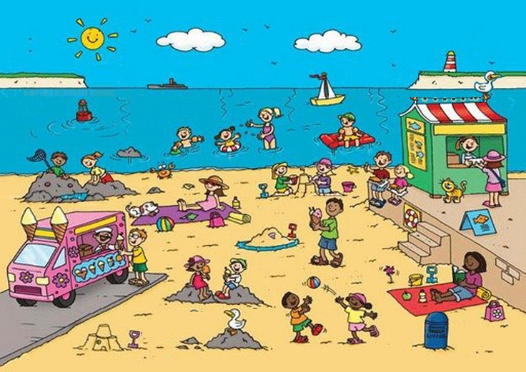
This is a picture of a beach side scene. There are a lot of children in this picture. The woman sitting on a ………………is reading a book. There is a …………….on her left side. There is a ………….on the top of the snack bar. A ……………is sailing in the water. There are some ………………in the sky.
Test 5
Match the headlines with their explanations.
1 TRIO SAVED IN CLIFFTOP DRAMA
2 MOTORWAY CRASH TOLL RISES
3 PM'S PLEDGE ON JOBS
4 POLICE BAN ON CIGERRETE
5 FISH SHOP BLAST RIDDLE
6 RAILMEN'S BID SET TO FAIL
7 DRUGS HAULT AT COLOMBO
8 BRIBES CASE SHAKES CABINET
9 AID FOR LANDSLIDE VICTIMS
10 PIT PERIL LIKELY
A The number of people killed in a motorway crash has gone up.
B A large amount of drugs has been discovered at Colombo Airport.
C There is still no explanation why an explosion happened in a fish shop.
D Railway workers' attempt to improve working conditions is expected to fail
E A dangerous situation is likely to arise in a graphite mine.
F Three people have been rescued from a dangerous cliff.
G Help is being sent to victims of an landslide.
H The police have stated that smoking is not allowed.
I The Prime Minister has promised to create more jobs.
J The Government's position has been weakened by a recent corruption case.
Test 6
Read the following conversation and fill in the blanks to complete the passage given thereafter.
Bryan : I stayed up all night yesterday to watch a James Bond movie Marathon.
Wife : It‟s more than clear from your swollen eyes,
Bryan. What‟s so special about the Marathon ?
Bryan : It brought back memories of my youth.
Wife : Were you a spy, Bryan ?
Bryan : No, I was a ticket collector at a cinema complex.
As Bryan’s wife brought him his morning tea, he yawned and announced that he stayed up all night the ……………. day to watch a James Bond movie Marathon. She was not amused to hear this. Handing him the tea, she casually remarked it was more than clear from his ……………. eyes and wanted to know what was so special about the Marathon. Bryan took a sip and said that it brought back ………………. of his youth. in order to tease him, she asked him sarcastically whether he was a spy. Bryan smiled and replied that he had been a ticket collector at a ……………… complex.

Test 7
Read the following notice and complete the sentences given below.
Missing Dog
Tiky, a German shepherd has been missing since 12th November, last seen waring a red collar with a name tag. The licence number is E2232. Tiky is a brown coloiur dog and has a white patch on its head. If found please contact the closest police station or call 011225413. A nice gift pack will be awarded to anyone who supplies the information.
The owner lost the dog on (1)……………………………….
The breed of the dog is (2)……………………….
E 2232 is its (3)…………………………..
The founder will be given an (4)…………………………
If found, you should address the nearest (5)……………………………..
Test 8
Write a short paragraph on one of the following. Use about 50-60 words.
- My future plans after O/L exam.
- What will be the world like in 2050.

