O/L English Language Model Paper
English Language 11
Two Hours
Test 9
The following passage contains 10 mistakes, such as grammatical errors, wrong prepositions and conjunctions. Correct the mistakes and rewrite the correct version of this passage.
On cold, wet morning, my class was filled with excitement. Someone (1) have discover that the next day was our teacher's birthday. Our teacher was the kindest person that ever (2) exist. Thus it (3) is no surprise she was the favourite teacher (4) to the pupils. Everyone (5) want to get her a present. I, very much wanted to (6) shown any appreciation too. That afternoon, I (7) spends the whole afternoon (8) shop for a present. After a long search, I finally made (9) on my mind. The next day I (10) gived her a bouquet of beautiful roses and she exclaimed with pleasure.
………………………………………………………………………………………………………………………………………………………………………….
………………………………………………………………………………………………………………………………………………………………………….
………………………………………………………………………………………………………………………………………………………………………….
………………………………………………………………………………………………………………………………………………………………………….
………………………………………………………………………………………………………………………………………………………………………….
………………………………………………………………………………………………………………………………………………………………………….
………………………………………………………………………………………………………………………………………………………………………….

Test 10

Choose the best (most logical) response to complete each of the following sentences:

1. This job is too …………………. (stressed-out/stressful).

2. There's a lot of work, but I can ………………………(deal/handle) it.

3. I was ………………….. (hired/heard) last month.

4. They ……………………..(fired/failed) two of my co-workers, and I'm afraid I might be next.

5. I work ……………………… (at/in) sales.

6. My ……………………………(commute/communion) (= the time it takes me to get to work) isn't so bad.

7. The company has a reputation for treating their ………………………..(employees/employed) well.

8. I usually don't eat in the ………………………….. (lunchroom/lunch-zone). I go out to eat.

9. The dress ………………………..(code/cut) is casual.

10. I'm thinking about …………………………(quitting/stopping) my job.

Test 11
Complete the following passage from the words in the box. The first one is done for you.

Kamal is a writer. He writes for the Sunday Observer. He usually (0) Gets up at 6.30 every morning and has a bath around seven. He eats his (1) _____________ at eight. He lives in Dehiwala and he drives (2) _____________ car to work. It takes about an hour for him to drive to his office in Colombo Fort. Last night he had an interview with a minister and came home (3) _____________ Therefore, he got up very late today and he is not going to work. It is now nine o’ clock and he is having a late breakfast. Later this evening he is going to (4) _____________ a friend who is also a journalist. They are going to have dinner in a (5) _____________ restaurant in Colombo.
Visit Breakfast famous very late gets up his

Test 12
Question: Read the following conversation and write in reported speech
Man: Are you returning form the village?
Trader: Yes. I returned yesterday.
Man: What news do you bring of my family?
Trader: Your son has begun to walk now. He is an active young child.

………………………………………………………………………………………………………………………………………………………………………….
………………………………………………………………………………………………………………………………………………………………………….
………………………………………………………………………………………………………………………………………………………………………….
………………………………………………………………………………………………………………………………………………………………………….
………………………………………………………………………………………………………………………………………………………………………….
………………………………………………………………………………………………………………………………………………………………………….
………………………………………………………………………………………………………………………………………………………………………….

Test 12

Write 05 sentences about the following picture.

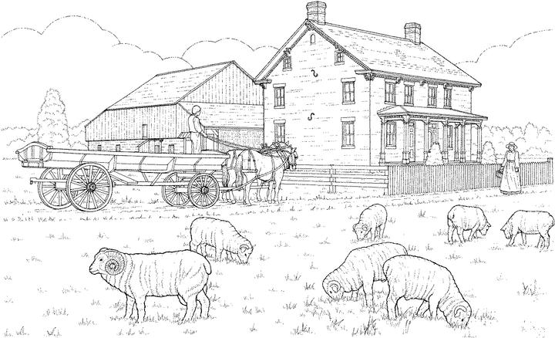

………………………………………………………………………………………………………………………………………………………………………….
………………………………………………………………………………………………………………………………………………………………………….
………………………………………………………………………………………………………………………………………………………………………….
………………………………………………………………………………………………………………………………………………………………………….
………………………………………………………………………………………………………………………………………………………………………….
………………………………………………………………………………………………………………………………………………………………………….
………………………………………………………………………………………………………………………………………………………………………….

Test 13
Write a description about a good deed you have done. Use about 50 – 60 words.
Include the following:
- About your good deed.
- When and where it was done
- Who helped you
- How you felt on this day
………………………………………………………………………………………………………………………………………………………………………….
………………………………………………………………………………………………………………………………………………………………………….
………………………………………………………………………………………………………………………………………………………………………….
………………………………………………………………………………………………………………………………………………………………………….
………………………………………………………………………………………………………………………………………………………………………….
………………………………………………………………………………………………………………………………………………………………………….
………………………………………………………………………………………………………………………………………………………………………….

Test 14
The following line graph shows the dengue fever pattern in Sri lanka during the period 2002 – 2014. Study the graph and write a description about it. Use about 100 words.
The following words may help you: highest, lower than, higher than, very little, increase, decrease, minimum, maximum.
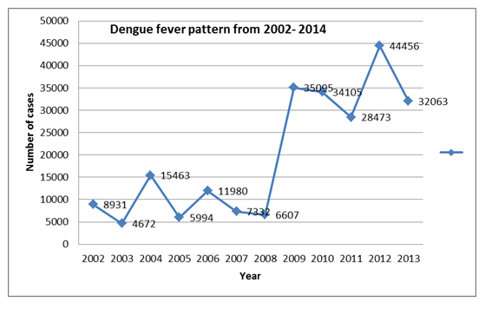

………………………………………………………………………………………………………………………………………………………………………….
………………………………………………………………………………………………………………………………………………………………………….
………………………………………………………………………………………………………………………………………………………………………….
………………………………………………………………………………………………………………………………………………………………………….
………………………………………………………………………………………………………………………………………………………………………….
………………………………………………………………………………………………………………………………………………………………………….
…………………………………………………………………………………………………………………………………………………………………………
………………………………………………………………………………………………………………………………………………………………………….
………………………………………………………………………………………………………………………………………………………………………….
………………………………………………………………………………………………………………………………………………………………………….
………………………………………………………………………………………………………………………………………………………………………….
………………………………………………………………………………………………………………………………………………………………………….
………………………………………………………………………………………………………………………………………………………………………….
………………………………………………………………………………………………………………………………………………………………………….

Test 15

Read the following text and answer the questions given below it.

Tiya had to leave for home before it got dark, because mother was waiting for him to bring a pot of drinking water from the well at the foot of Pidurangala. The water in this well was so clean and sweet unlike the water found in the wells of their village and in most other villages which was brackish. It had been a habit started by his brother when he worked at Sighiri before Tiya took over from him. In the morning he would bring the empty pot and leave it under a tree near the well and on the way back in the evening he would have his bath at the well just below the temple building, fill the pot with water from the well and carry it home, together with the share of anything he had received as payment for his services as a tour guide that day. His grandma Bohodevi has explained to him that the water is so pure probably because of the Kumbuk tree growing beside the well and he knew that hi grandma was right.

Tiya walked along the footpath leading to the village. He had to be very alert, for this is the time for the elephants would be coming out. He could hear one of them close by, breaking a branch off a tree, and there could be others around.

As he came in sight of village, which was on a small hillock overlooking their paddy fields, Tiya could hear children playing and see the smoke curling up towards the sky from a few houses, as the women cooked the evening meal. He wondered what mother had prepared that day, as he was feeling hungry after the bath. Mother wanted him to take his father’s meal to him at the quarry, as he was working through the night, and Tiya got mother to wrap his meal too at the same time, so he could have his dinner with his father and then watch him at work.

Tiya had to hurry and walk fast, to reach the work place before it got very dark. Long before he reached the place he could hear the regular rhythmic beat of iron on stone, as the craftsmen chipped the stone to carve and mould it the way they wanted. In their hands the stone was like clay, but it was much more difficult and painstaking, as the craftsmen had no room for any mistakes. Tiya went close to his father and stood by his side for he did want to distract him from what he was doing.

- What did mother expect Tiya to bring home? __________________________________ (1 mark) 2)
- What was Tiya’s brother before Tiya took over from him? _______________________ (1 mark)
- Write two words that describe the water in the well near Pidurangala.
(i) _______________________ (ii) _______________________ (2 marks)
- Underline the correct answer? As Tiya walked along the footpath he could hear
(a) Children playing (b) elephants moving (c) craftsmen working (1 mark)
- Where did Tiya’s father work ________________________________________________ (1 mark)
- Why did Tiya get his mother to wrap his meal too? Write two reasons.
- (i) _________________________________________________________________________
(ii) _________________________________________________________________________ (2 marks) What do the following refer to?
Others (in paragraph 2 line 3) _____________________________________________
He (in paragraph 3 line 5) _____________________________________________ (2 marks)

Test 16
.
Write an essay on ONE of the following. Use about 200 words.
1. The value of reading for a successful future. You can include the following if you like.
a. Academic benefits of reading
b. How it can help you to relax your mind
c. Where you can find good books to read.

2. Write an article to your school magazine about an education TV talent show programme you enjoyed watching. Use the ideas given below.
a. When and where you watched the programme
b. Who did you watch it film with
c. The story in brief
d. What did you enjoy watching? Was it the music, the participant , the judgment etc.…

